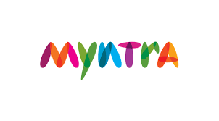

Myntra is a major Indian [fashion](https://en.wikipedia.org/wiki/Fashion) [e-commerce](https://en.wikipedia.org/wiki/E-commerce) company headquartered in [Bengaluru](https://en.wikipedia.org/wiki/Bengaluru), [Karnataka](https://en.wikipedia.org/wiki/Karnataka), [India](https://en.wikipedia.org/wiki/India). Myntra is a one stop shop for all your fashion and lifestyle needs. Being India's largest e-commerce store for fashion and lifestyle products, Myntra aims at providing a hassle free and enjoyable shopping experience to shoppers across the country with the widest range of brands and products on its portal. The brand is making a conscious effort to bring the power of fashion to shoppers with an array of the latest and trendiest products available in the count

**Important evolution over the years:**

|  |  |
| --- | --- |
| **Years** | **Milestones** |
| 2007 | Established by Mukesh Bansal along with Ashutosh Lawania and Vineet Saxena. It sold on-demand personalized gift items. It mainly operated on the B2B (business-to-business) model during its initial years |
| 2010 | Between 2007 and 2010, the site allowed customers to personalize products such as T-shirts, mugs, mouse pads, and others |
| 2011 | Myntra began selling fashion and lifestyle products and moved away from personalization ,By 2012 Myntra offered products from 350 Indian and International brands. The website launched the brands Fastrack Watches and Being Human |
| 2014 | Myntra was acquired by [Flipkart](https://en.wikipedia.org/wiki/Flipkart). Its portfolio included about 1,50,000 products of over 1000 brands, with a distribution area of around 9000 pin codes in India |
| 2015 | Ananth Narayanan became the Chief Executive Officer of Myntra. It acquired Bengaluru-based mobile app development platform company Native5  It announced that it would shut down its website, and serve customers exclusively through its mobile app beginning. It acquired their rival Jabong.com to become India’s largest fashion platform |
| 2016 | The move received mixed reception, and resulted in a 10% decline in sales. In February 2016, acknowledging the failure of the "app-only" model, Myntra announced that it would revive its website. |
| 2017 | Myntra negotiated the rights to manage Esprit Holdings 15 offline stores in India |
| 2020 | Myntra changed its logo Added over 100 brands to its BPC |

**Business Model of Myntra**

The business model of any company is the strategy it uses to gain a larger market space. The chart describes the business model of Myntra in tabular form.

|  |  |  |
| --- | --- | --- |
| **Value Proposition**  ·        **Fast delivery time**  ·        **Wide Selection**  ·        **Sales**  ·        **Quality Products** | **Key Resources**  ·        **Delivery Staff**  ·        **IT infrastructure** | **Key Activities**  ·        **Partnership with distributers**  ·        **Marketing**  ·        **Sales**  ·        **Supply Chain optimization** |
| **Key Partners**  ·        **Seller**  ·        **Distributers** | **Key Channels**  ·        **Website**  ·        **App**  ·        **Affiliate program** | **Customer Relationship**  ·        **Customer Service**  ·        **Customer Support**  ·        **Easy To use App** |
| **Customer Segmentation**  ·        **Fashion enthusiasts**  ·        **Discount Lovers** | **Cost Structure**  ·        **Marketing**  ·        **Technology** | **Revenue Stream**  ·        **Commission Structure**  ·        **Own sale** |

**Government Norms for Myntra:**

Since 2014, the Government of India has announced various initiatives, namely Digital India, Make in India, Start-up India, Skill India and Innovation Fund. Some of the major initiatives taken by the Government to promote E-commerce in India are as follows:

* In a bid to systematise the onboarding process of retailers on e-commerce platforms, the Department for Promotion of Industry and Internal Trade (DPIIT) is reportedly planning to utilise the Open Network for Digital Commerce (ONDC) to set protocols for cataloguing, vendor discovery and price discovery. The department aims to provide equal opportunities to all marketplace players to make optimum use of the e-commerce ecosystem in the larger interest of the country and its citizen.
* The Consumer Protection (e-commerce) Rules 2020 notified by the Consumer Affairs Ministry in July directed e-commerce companies to display the country of origin alongside the product listings. In addition, the companies will also have to reveal parameters that go behind determining product listings on their platforms.
* Government e-Marketplace (GEM) signed a Memorandum of Understanding (MoU) with Union Bank of India to facilitate a cashless, paperless and transparent payment system for an array of services in October 2019.
* Under the Digital India movement, Government launched various initiatives like Umang, Start-up India Portal, Bharat Interface for Money (BHIM) etc. to boost digitisation.
* In October 2020, Minister of Commerce and Industry, Mr. Piyush Goyal invited start-ups to register at public procurement portal, GEM, and offer goods and services to government organisations and PSUs.
* In October 2020, amending the equalisation levy rules of 2016, the government mandated foreign companies operating e-commerce platforms in India to have permanent account numbers (PAN). It imposed a 2% tax in the FY21 budget on the sale of goods or delivery of services through a non-resident ecommerce operator.
* In order to increase the participation of foreign players in E-commerce, Indian Government hiked the limit of FDI in E-commerce marketplace model to up to 100% (in B2B models).
* Heavy investment made by the Government in rolling out fibre network for 5G will help boost E-commerce in India.

**Future Policies**

* Ban on specific flash sale by e commerce entity
* Restrict e commerce from manipulative search result and search indexes, Removal of pre-ticked check boxes
* Any online retailer first itself have to register itself with Department of promotion for industry and internal trade
* Any entity having 10 % or more common ultimate beneficial ownership will be considered as associate enterprise of an ecommerce platform
* The new policies will not allow be to enlisted as a seller of an associate enterprise
* On a line of IT intermediatory rule appointment of grievance officer a chief compliance officer and a nodal contact person for 24*7 coordination with law enforcement agency
* When the government requests information, platform should provide it within 72 hours by the authority

**Market Structure:**

* Market Structure breakdowns into various categories based on the number of sellers, type of products, and the level of market penetration.
* Myntra is categorized into an oligopolistic market as it offers same services to same range of products.
* Myntra is the biggest reseller of fashion brands in India. Myntra has been keen in procuring private brands and labels. Myntra partners with more than 2K fashion brands and lifestyle brands and services over 19K pin codes across the country.

**Market Share:**

Myntra (along with Parent Flipkart) continue to hold 60% market share in online fashion retail, according to a Bank of America report. The revenue from these private labels nearly gives about 30% of its total revenue.

**Myntra Key Resources**

The channels through which Myntra operates are its applications and website. It also operates through affiliate programs.

Key Channel : Website , App, Affiliated Program

**Myntra Cost Structure :-**

Myntra spends most of the revenue in purchasing stock in trade.

Cost Structure :- Marketing , Technology

Additionally, Myntra spends on technology up-gradation and infrastructure improvement. Other than that, it also has to spend on warehouse management and advertisements. Salary to workforce comes under the fixed cost of Myntra.

**Myntra’s Revenue Streams - How does Myntra Make Money?**

Myntra earns through an aggregator model. It buys current season merchandise from various brands and makes the product available on its website. It earns through commission. The revenue model of Myntra is that of B2C (Business to customer) now.

Revenue stream:- Commission Structure , Own Sale.

**Product Strategy:**

* **Scale**

Revenue  :  Rs 1,719 crore/$233.4 million for the financial year 2019-20

Net Worth : $9.65 million The company saw its employee benefit expenses go up to Rs 425.20 crore in FY'19 from Rs 279.39 crore in the previous fiscal, while total expenses for the fiscal were at about Rs 1,628 crore.

The firm has made investment amounting to $48.75 in the paid-up share capital of Myntra Inc. which comprises 4,875,000 equity shares. Myntra Inc. is engaged in the business of research and development in the field of internet technology.

* **Scope**

The revenue of the firm is mainly generated from services related to marketplace, logistics and consultancy to various brands. However, the company is considering and exploring viable business opportunities with financial support from its intermediate holding company

Myntra expanded in international markets. It forayed into the Middle East and launched Myntra Fashion brands there. The company partnered with the leading regional e-commerce platforms, noon.com and namshi.com to offer brands of Indian origin to millions of fashion-forward shoppers in the region.

* **Size**

 Increase of customer by 86% in lockdown in the number of customers from tier 2 and 3 cities - the highest so far.

15 million items on sale from six million orders. Beauty and personal care, kids wear and casual wear to contribute to 50 per cent of demand.

40% shoppers expected to come from tier-2 & 3 cities and towns.Geared to handle over 800,000 concurrent users at peak

 Scaled up to handle 12,000 orders per minute at peak. 17,700 kirana partners to cater to 80% of the overall deliveries spanning 600 cities

* **Breakeven**

Myntra recently witnessed a record-breaking number of visitors at 15 million on the opening day of its flagship sale event End of Reason Sale (EORS). It registered a massive growth of more than 110 per cent over BAU (business-as-usual). The event started with Myntra selling over 3 million items within the first 24 hours, clocking more than 2X growth over the June.

* **Profit and loss analysis**

Myntra reported a net loss of ₹151.20 crore in the financial year 2017-18.Myntra also posted an 80% drop in revenue FY18 as a big chunk of its sales were moved to a new entity that was formed after its acquisition of rival Jabong in 2016. Myntra clocked a 57.8% rise in its net total income to Rs 1,718.5 crore for FY20, as against Rs 1,088.8 crore for the financial year ended March 2019.For the year 2019-20, the company reported a 58% jump in revenue at ₹1,719 crore. Online fashion retailer Myntra Designs saw its loss widening to Rs 744.4 crore for the financial year ended March 2020, according to regulatory documents.

**Competitive Strategy:**

Myntra’s top competitors include Yepme, Amazon, LimeRoad, Snapdeal, Voonik, Zopper, HSN, GoRootz, Fynd and Flipkart. The competitive advantage of e-commerce companies is mainly because of cost leadership or product differentiation. With Myntra, it is because of cost leadership. However, before 2010, Myntra also had gained market space in product differentiation by providing customised t-shirts and mugs. For instance, during IPL, Myntra provides t-shirts with a person’s name printed on it.

Taking an example of AJio which is levelling up with Myntra:

* In April 2016, at the Lakme Fashion Week, Mukesh Ambani’s Reliance announced its big foray into fashion e-commerce with AJIO.com. The segment that has been crowded by the likes of Flipkart, Myntra (along with Jabong back then), Amazon, and others, left little room for AJIO to outshine the others.But the rise of e-commerce, especially as it spreads into rural India has brought about changes in the fashion e-commerce landscape. AJIO, which up until a year ago, wasn’t even counted among the frontrunners is scripting a story of resurgence now.
* In its recent earnings report, Reliance said that AJIO has scaled new highs with 4x growth in orders from pre-COVID levels.
* AJIO’s latest numbers show that it’s levelling up to Myntra while moving fast ahead of other competitors like Tata Cliq, Snapdeal and Koovs.
* However, Flipkart and Myntra continue to hold 60% market share in online fashion retail, according to a Bank of America report.
* Currently, fashion and lifestyle account for just 9% of the total retail sales of Reliance.

**How Myntra reacting towards the competitors:**

A number of changes are being incorporated in terms of functioning as well as infrastructure to ensure it can keep up with customer demands and requirements.

1. Three-fold increase in warehouse capacity– Its current 1,50,000 sq.ft warehouse will be expanded to 4,50,000 sq ft for which it has commissioned two state-of-the-art automated warehouses in Bangalore and Gurgaon, to be operational by the next quarter.
2. Increase in workforce- A new office has been setup in Bangalore to accommodate the increase in workforce from 700 to 2,600.
3. Increase in private labels– The number of tie-ups with private labels has been  increased to 14 from the current 8.
4. Increase in revenue from its own brands- Currently, Myntra’s own labels/brands like Roadster contributes to 20-25% of its revenue. This is expected to increase to about one-third in the coming 12-18 months.
5. Private labels will be available for sale on Flipkart too, and will probably be expanded to other platforms soon.
6. Physical stores- It will open physical stores in cities like Bangalore, Delhi and Mumbai in the next 18 months to enable customers to touch and feel its private labels to hike their sales.

Myntra has put these robust expansion plans into action in light of the $50 million funding it received from Premji and other group of investors in February and acquisition by Flipkart recently (valued at $350-370 million). Additionally, Flipkart is expected to pump close to $100 million in the next few quarters.

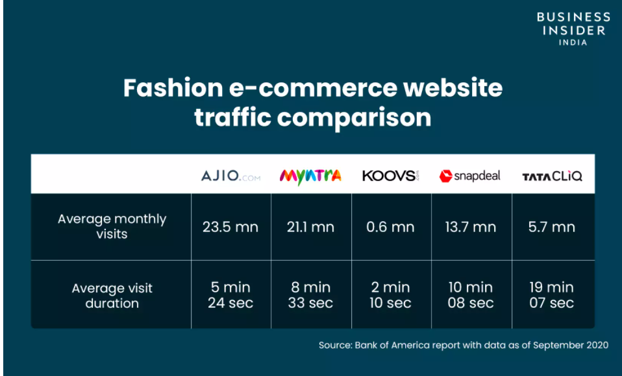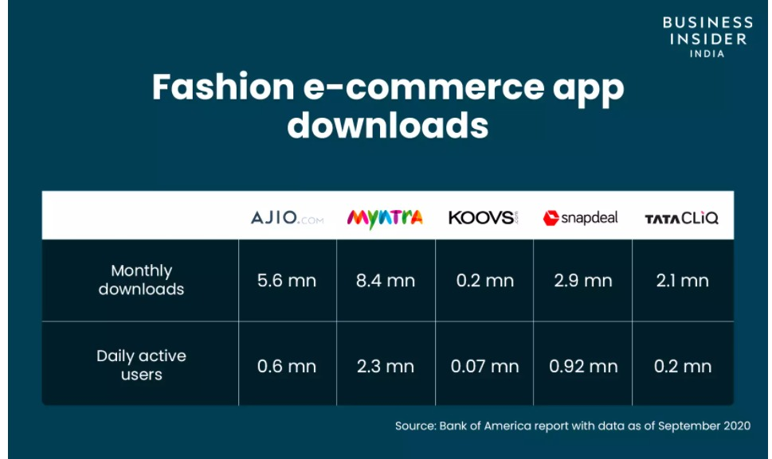

**Disruptions**

**One of the Major Problem Faced by Myntra**

**Redelivery and Return:**

Myntra, being a leading fashion e-commerce site, with a whopping customer base of 15 million on average, has its own problems.

The company is trying to reduce its losses due to frequent returns and exchange requests from customers due to wrong product sizes, Fabric Quality, or product colors. These may induce bad reviews and a reduced customer return rate.

The ultimate goal of the company with this problem statement is to reduce product returns, pickup & re-delivery costs, get better reviews, and increased customer return rates.

What does a user expect from a company?

The users’ needs are simple. They expect correct fitting clothes, good fabric quality, accurate color and satisfaction from the purchase, no stress about returns and re-delivery waiting.

This the analysis of how user search and shop in general :

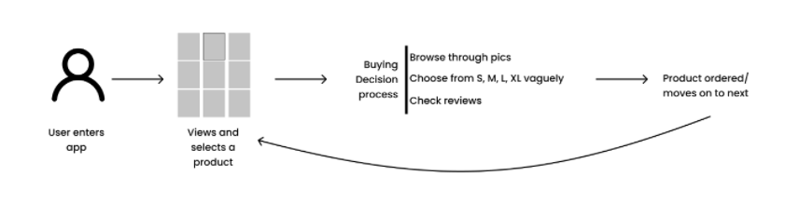

These are the features used generally by user during the shopping

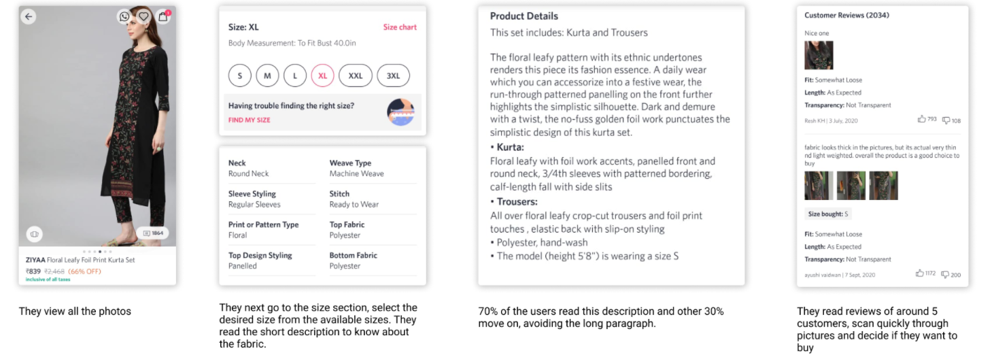

In today’s time the patience level of the user is not very high. They don’t spend too much time on the product page and hence miss out on important features. These are the least explored, yet more useful parts of the page. These are called translucent features. They are either small or are away from the main page by 2–3 clicks.

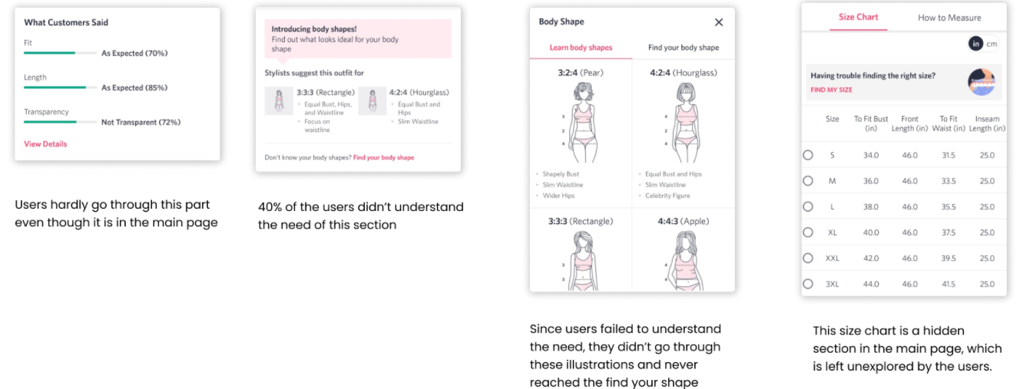

Possible solutions

* Get a similar fitting brand size and compare it with the selected dress.
* Show various photos with different shaped models, with their size specifications.
* Keep specific size inputs in the main page and products display page and show recommendations with similar body shape models
* Introduce AR view (try-on feature) with the 270-degree view video capture to know how the color works on them.
* Add review videos or product catalog videos with different types of models wearing, to show color, fit, the flow of fabric, transparency, weight, and the quality of the fabric.

**Future Perspective of Myntra:**

* Myntra on its journey towards digital transformation

With this digital transformation, Myntra has migrated its platform from supply change management to site capability to Azure cloud which will minimise security breaches and will support “Pay as you Go “Model.

* Office Expansion of Myntra Stores

Launched 1000 new outlets by now and planning to grow the network across the globe.

* Style Exchange: First of its kind in E-commerce:

Till now exchange in e-commerce is only supported for similar products but with Style Exchange customers can now exchange heterogeneous products for the same price.

* Aiming to hit 1 billion Revenue Mark
* With the help of all above strategies, Myntra is planning to grow its sales threefold by 15 months and aiming to reach 1 billion dollar (6300 Cr Indian Rupees) revenue mark.

**Conclusion**

Myntra has become a worth competing fashion e-commerce company because of its unique business model and attractive discount offers. Myntra also keeps on revising its business strategies with exigencies of time. It started with the B2B model and shifted to the B2C model. Thus Myntra offers good competition to e-commerce companies, especially in the apparels sector.